# LoopVerse Web Development Challenge

**Project Title: SkillSphere** - A Real-Time Microlearning & Mentorship Platform

Project Report

By:

Alisha Siddiqui

Team: DOMinator

Solution:

**Executive Summary**

SkillSphere is a comprehensive online mentoring and skill development platform that connects learners with expert mentors across various technology domains. The platform facilitates one-on-one and group mentoring sessions, provides AI-powered learning assistance, and includes advanced features like real-time chat, video conferencing, and progress tracking.

**Problem Statement & Solution**

**Original Problem**

* **Lack of accessible, quality mentorship** in technology fields
* **Fragmented learning resources** without personalized guidance
* **No centralized platform** for skill-based mentoring
* **Difficulty in finding qualified mentors** with specific expertise
* **Limited interactive learning experiences** with real-time collaboration

**Implemented Solution**

SkillSphere provides a **comprehensive mentoring ecosystem** that addresses these challenges through:

1. **Mentor-Learner Matching System** - Algorithm-based matching based on skills, availability, and learning goals
2. **Interactive Session Management** - Real-time video sessions with whiteboard collaboration
3. **AI-Powered Learning Assistant** - Context-aware guidance and recommendations
4. **Progress Tracking & Analytics** - Comprehensive learning journey monitoring
5. **Real-time Communication** - Chat system with file sharing capabilities
6. **Admin Management System** - Complete platform oversight and moderation

**Database Design & Normalization**

**Database Architecture**

The database follows **Third Normal Form (3NF)** principles with proper entity relationships and foreign key constraints.

**Core Database Tables**

**1. User Management Tables**

**2. Skills & Expertise Tables**

**3. Session Management Tables**

**4. Booking & Payment Tables**

**5. Communication Tables**

**6. AI Integration Tables**

**7. Analytics & Review Tables**

**Database Normalization Analysis**

**First Normal Form (1NF)**

* ✅ All tables have primary keys
* ✅ No repeating groups or arrays in single columns
* ✅ Each cell contains atomic values

**Second Normal Form (2NF)**

* ✅ All non-key attributes depend on the entire primary key
* ✅ Composite keys properly handled (e.g., user_skills, session_participants)
* ✅ No partial dependencies

**Third Normal Form (3NF)**

* ✅ No transitive dependencies
* ✅ Separated master data (skills, users) from transaction data (sessions, bookings)
* ✅ Lookup tables properly normalized

**Key Database Features**

1. **Referential Integrity** - All foreign keys properly constrained
2. **Indexing Strategy** - Optimized for common queries (user_id, session_id, timestamps)
3. **Soft Deletes** - is_active flags for data preservation
4. **Audit Trail** - created_at, updated_at timestamps
5. **Scalability** - Designed for horizontal scaling with proper partitioning potential

**Technology Stack**

**Backend Architecture**

**Frontend Architecture**

**AI Integration**

**DevOps & Infrastructure**

**Third-Party Integrations**

**Technical Approach & Architecture**

**1. Modular Backend Architecture**

**Django Apps Structure**

**API Design Pattern**

* **RESTful API** design with consistent endpoint patterns
* **ViewSets and Serializers** for CRUD operations
* **Custom Permission Classes** for role-based access
* **Pagination and Filtering** for large data sets
* **API Versioning** for backward compatibility

**2. Component-Based Frontend Architecture**

**React Component Hierarchy**

**State Management Strategy**

* **React Context** for global state (user authentication, theme)
* **Local State** (useState) for component-specific data
* **Custom Hooks** for reusable state logic
* **Service Layer** for API calls and data caching

**3. Real-time Communication Architecture**

**WebSocket Implementation**

**Frontend WebSocket Integration**

**4. AI Integration Architecture**

**AI Service Layer**

**Context-Aware AI Responses**

* **User Role Detection** - Different responses for learners vs mentors
* **Session Context** - AI aware of current session details
* **Learning History** - Recommendations based on past interactions
* **Skill Gap Analysis** - Intelligent skill assessment and improvement suggestions

**5. Security & Performance Approach**

**Authentication & Authorization**

**Performance Optimization**

* **Database Query Optimization** - Select_related and prefetch_related
* **API Response Caching** - Redis caching for frequently accessed data
* **Frontend Code Splitting** - Lazy loading of route components
* **Image Optimization** - Compressed images and lazy loading
* **WebSocket Connection Pooling** - Efficient real-time communication

**6. Scalability Considerations**

**Backend Scalability**

* **Microservices Ready** - Modular Django apps can be extracted
* **Database Sharding** - User-based partitioning potential
* **Horizontal Scaling** - Stateless API design
* **Load Balancing** - Multiple Django instances support

**Frontend Scalability**

* **Component Reusability** - Modular component architecture
* **Code Splitting** - Route-based and component-based splitting
* **Progressive Web App** - Service worker implementation ready
* **Mobile Responsive** - Single codebase for all devices

**Key Features Implemented**

**1. Advanced Session Management**

* Multi-step booking flow with mentor selection
* Recurring session packages with discounts
* Group session support with participant management
* Real-time video integration with WebRTC
* Virtual whiteboard and screen sharing

**2. Intelligent AI Assistant**

* Context-aware responses based on user role
* Learning path recommendations
* Skill gap analysis and mentor matching
* Session preparation and follow-up suggestions
* Real-time chat integration

**3. Comprehensive Admin Panel**

* User management and role assignment
* Session monitoring and analytics
* Content moderation and reporting
* System health and performance metrics
* Revenue and engagement analytics

**4. Real-time Communication**

* WebSocket-based chat system
* File sharing and multimedia support
* Online/offline status indicators
* Conversation threading and search
* Integration with session workflow

**5. Advanced Analytics**

* Learning progress tracking
* Mentor performance metrics
* Revenue and booking analytics
* Skill development visualization
* Platform usage statistics

**Innovation & Technical Excellence**

**1. AI-Powered Learning Experience**

* **Contextual AI Assistant** that understands user journey
* **Intelligent Mentor Matching** based on skills and learning goals
* **Adaptive Learning Paths** that evolve with user progress
* **Real-time Session Assistance** during live mentoring sessions

**2. Seamless User Experience**

* **Progressive Web App** capabilities for mobile users
* **Real-time Updates** across all platform interactions
* **Responsive Design** optimized for all device types
* **Accessibility Compliance** following WCAG guidelines

**3. Scalable Architecture**

* **Modular Backend Design** enabling independent service scaling
* **Component-Based Frontend** promoting code reusability
* **Database Optimization** with proper indexing and relationships
* **Caching Strategy** for improved performance

**Conclusion**

SkillSphere represents a comprehensive solution to the modern mentoring and skill development challenge. Through careful database design, robust backend architecture, and intuitive frontend implementation, the platform delivers:

1. **Accessible Mentorship** - Connecting learners with qualified mentors globally
2. **Interactive Learning** - Real-time video sessions with collaborative tools
3. **AI-Enhanced Experience** - Intelligent recommendations and learning assistance
4. **Scalable Platform** - Architecture ready for growth and feature expansion
5. **Data-Driven Insights** - Analytics for continuous platform improvement

The technical implementation demonstrates modern software development best practices, including proper database normalization, RESTful API design, component-based frontend architecture, and real-time communication integration. The platform is positioned to scale effectively while maintaining high performance and user experience standards.

SkillSphere successfully bridges the gap between learners seeking guidance and mentors sharing expertise, creating a thriving ecosystem for professional development and knowledge transfer.

Implementation:  
Register page:

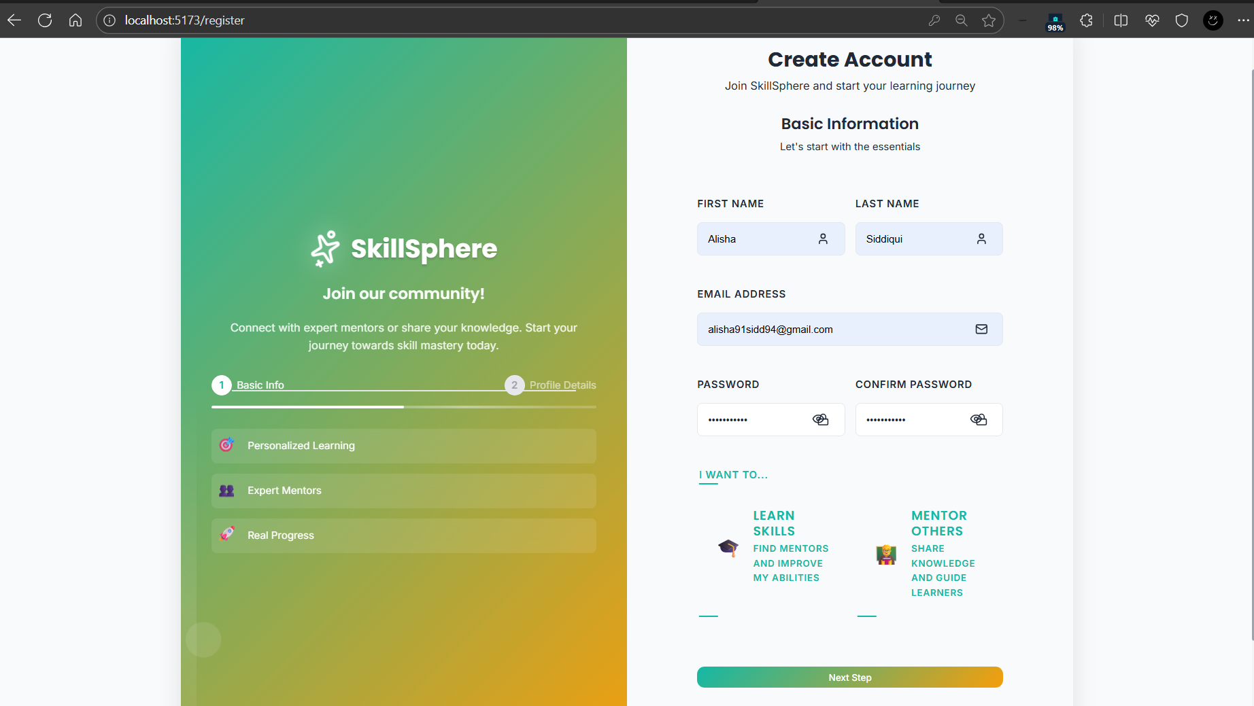

Login page:

Learner Dashboard:

Session booking:

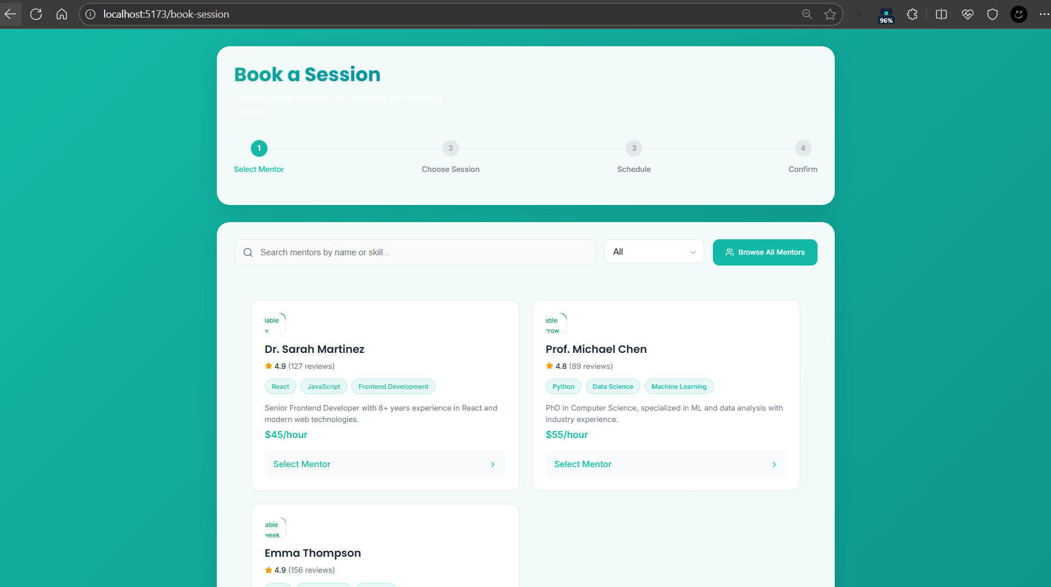

Chat feature:

Browsing mentors:

Mentor dashboard:

Messages:

Ai assistant:

